B.C.M. Sen. Sec. School, Basant City, Pkh. Road, Ludhiana.
Name ___________________ Roll No._____ Standard III
Chapter ( Introduction To Computers )
- Join the dots and write what you get. Colour it.
- Draw and colour ‘Monitor. III. Draw and colour ‘Mouse’.

- Draw and colour ‘Calculator’.

- Answer the following questions:
- What is processing?
Ans. The work done by the CPU on the given data or input is called processing.
- What is computer hardware?
Ans. Computer hardware is the collection of all the physical parts that we can touch.
- What do you understand by Operating System? Give two examples.
Ans. Operating System is system software that controls and manages the activities of
the computer. Examples are Windows 7, Windows 10.
- What is computer software?
Ans. Software is a set of programs that tell the hardware how to perform a specific task.
- Can you operate hardware without the software? Why?
Ans. No, hardware cannot work alone. Software makes the hardware parts work.
- State T for true statement and F for false statement:
  - The instructions that you give to the computer is called input.
  - The computer does not use IPO cycle to perform a task.
  - There are three types of software.
  - The devices which are used to show the result are known as input devices.
  - Operating system is not a part of system software.
  - Computer follows three steps.
  - When you start your computer, software also starts with it.
- Identify the following pictures and name them.
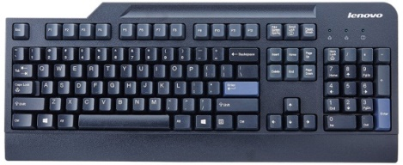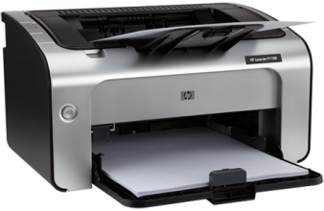
Windows 7 Keyboard Printer

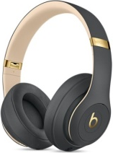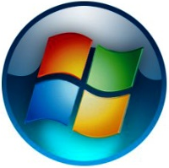
Headphone Start Button
- Identify the following as system Software/Application Software:
Software | System | Application
Paint
Windows 7
Solitaire
Calculator
Windows 10
- Application-based Questions
- Vivek’s teacher show him the internal part of the CPU box. But he forgets the name of main board. Help him to know about that board.
Ans. Motherboard
- Simar wants to create a birthday greeting card for her mother. Which application software will she use?
Ans. Paint

